ITINERARY

RCBC River Run
‘Running Adrift
in 2026’

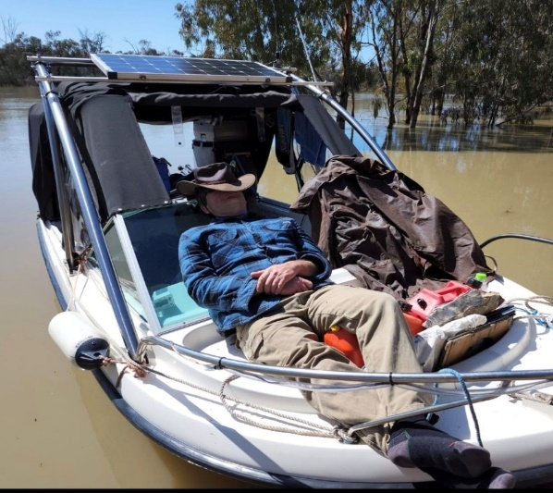

Berri to Morgan Monday 11th May to Thursday 21st May 2026 Closing Date: Sunday 29th March 2026

EVENT ORGANISERS: If you have any questions, please contact
David Jones – Krackacan 0490 126 916 Sandi Todd – LuLu 0418 845 115

Day/Date | Location | Klm mark | What’s happening | Services
11 May  Mon  Day 1 | Berri Marina  Opp Berri Caravan Park | 526 | Registrations  Krackacan  Berri Hotel  Welcome Dinner 6pm  Own expense | Trailer transfers, fuel, shopping, pump out.  Vehicle access  Caravan Park
12 May  Tue  Day 2 | Whirlpool Bend  16 klm  Lock 4 | 510 | Happy Hour 4.30pm  Self cater, camp fire  Raffles, games | No vehicle access
13 May  Wed  Day 3 | Raines Bend  40 klm | 474 | Happy Hour 4.30pm  Self cater, camp fire  Raffles, games | No vehicle access
14 May  Thu  Day 4 | Moorook  22 klm | 452 | Optional take away from General store. Own expense. Otherwise, self cater.  Happy Hour 4.30pm  Raffles, games | General store, fuel, dump point  Road access, caravan parking
15 May  Fri  Day 5 | Overland Corner  26 klm  Lock 3 | 426 | Overland Cnr Pub  Dinner 6pm. Own expense  Transport available | Road access  Caravan parking
16 May  Sat  Day 6 | Holder Bend  40klm | 386 | Early start – big day  Happy Hour 4.30pm  Self cater, camp fire  Raffles, games | Road access  Caravan parking
17 May  Sun  Day 7 | Waikerie  4 klm  RCBC 40th Birthday Celebration. | 382 | RCBC 40th Birthday  Lunch at Hotel  12pm for 12.30 lunch  All RCBC members will have their meal paid to a capped amount of $35.00  Non members at own expense  Transport up hill on needs basis  Happy Hour 4.30pm  Self cater for dinner | Shops, fuel, pump out  Vehicle access  Caravan Park
18 May  Mon  Day 8 | Paul’s Sandbar  28 klm  Lock 2 | 358 | Happy Hour 4.30pm  Self cater, camp fire  Raffles, games | No vehicle access
19 May  Tue  Day 9 | Opposite Caudos  10 klm | 348 | Short trip-almost a lay day  Happy Hour 4.30pm  Self cater, camp fire,  Raffles, games | No vehicle access
20 May  Wed  Day 10 | Morgan  8 klm | 320 | Presentation Night  Hotel TBA 6pm for 6.30pm  Own expense | Fuel, shop, pump out  Vehicle access  Caravan Park
May 21  Thu  Day 11 | Morgan River Front  Krackacan mooring | 320 | BBQ breakup breakfast  8am-10am  Catered by RCBC | Time for hugs, good byes, thanks and see you next time.

GENERAL INFORMATION

Land Lubbers: Information re vehicle access, caravan parking etc has been provided for members who may want to join the fleet for on shore activities. If this is you, please fill in the registration form providing your transport information in the boat info area.

Registrations: A booklet with a detailed daily running sheet, including maps will be provided to each boat on Day 1 at the Berri Marina. Visit Krackacan mooring.

Name Badges: Each captain and crew member will be provided with a numbered name badge. These numbered name badges will also be used during events. Please wear them at all times to assist in getting to know each other. *No name badge, no prize and a gold coin fine to boot*

Happy Hour and Daily Briefings: Held each afternoon at 4.30pm

Raffles: Drawn most afternoons at Happy Hour from the wrapped presents provided. There will be no charge for the raffle. Your numbered name badge will be used for the draw.

Activities: There will be a number of activities organised during the run. Details provided at Happy Hour

Medical: There are several members with medical backgrounds and / or first aid certificates. Details will be provided in the booklet provided on Registration.
A Confidential Medical Form has been provided. You are encouraged to fill in one form for each crew member. Place in a sealed envelope and keep near the helm. The forms will only be used in an emergency and the information will only be shared with those involved in your care.

Non RCBC Members – Members of other boating clubs have been invited to join RCBC members for our River Run. If you are from another club, please fill in your membership details on the Registration form.

