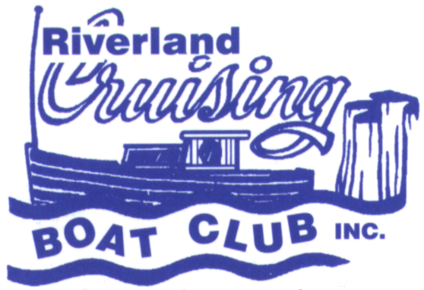
RIVERLAND CRUISING BOAT CLUB
P.O. BOX 1496,
RENMARK, SOUTH AUSTRALIA 5341

Email: secretary@riverlandcruisingboatclub.org.au

Website: www.riverlandcruisingboatclub.org.au

Facebook: https://www.facebook.com/groups/riverlandcruisingboatclub
ABN:46 457 392 781
BSB 105052 Account: 50489140

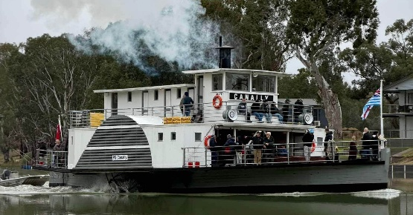
REGISTRATION FORM
PS Canally and North West Bend Trip

DATE Saturday 5th September 2026

EVENT ORGANISER/S: Paul and Judy Knifton

Trip from Morgan on the PS Canally to North West Bend Station for lunch and return with the possibility of cruising further upstream or downstream (depending on when we leave NWB Station after lunch) as we have use of the Canally for 6 hours.
The Canally can take 50 passengers so RCBC members will get first preference, if we do not fill the numbers by registration day we will open it up for other people.
Any questions please contact us. Paul 0412 661 733 Judy 0403 360 219

COST FOR CANALLY RETURN TRIP: $50.00 pp
Lunch at NWB at own cost, pay on the day. Please see the menu below.

ARRIVAL TIME PRIOR TO DEPARTURE: 9.30am
CANALLY DEPARTURE TIME: 10.00am
CANALLY RETURN TIME: 3.00pm with a possible extension to 4pm

CLOSING DATE FOR REGISTRATION: 21st August 2026

Details of all Registrants
NAME | PHONE NUMBER | EMAIL ADDRESS

Return your completed Registration Form via email to: secretary@riverlandcruisingboatclub.org.au

Registration Fee Payment:
Account Name: Riverland Cruising Boat Club (RCBC) BSB: 105 052 Account Number: 050 489 140
Please send a copy of your payment receipt to: Treasurer, Peter Cannon via email: pmcannon@adam.com.au

Signed: _____________________________ Date: ________________________

