RCBC River Run
‘Running Adrift
in 2026’

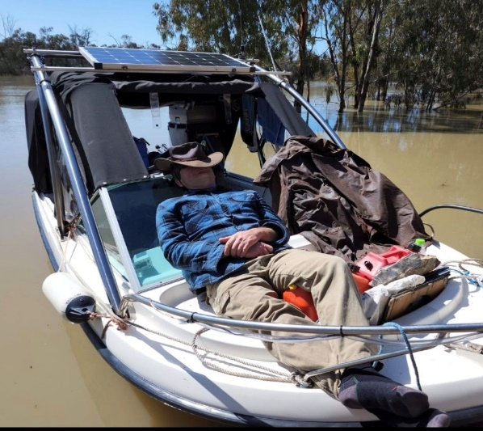

Berri to Morgan Monday 11th May to Thursday 21st May 2026 Closing Date: Sunday 29th March 2026

Entry Form
EVENT ORGANISERS: If you have any questions, please contact
David Jones – Krackacan 0490 126 916 Sandi Todd – LuLu 0418 845 115
REGISTRATION FEE: $50 per boat.

NAME: |  |  | PHONE:  Mobile
POSTAL ADDRESS:
EMAIL ADDRESS
TYPE OF BOAT (Please Tick) | HOUSEBOAT □ | HALF CABIN □ | TRAILER SAILER □ |  |  | CRUISER □
TYPE OF BOAT (Please Tick) | OTHER □ (Please describe)
LENGTH OF BOAT |  | NAME OF BOAT
ADDITIONAL PASSENGERS  Name: |  | Phone: |  | Email:
FURBABIES – Name: |  | Breed/colour |  | Size: Small Medium Large

MEMBERSHIP DETAILS

Are you a financial member of Riverland Cruising Boat Club? | YES | NO
Are you a financial member of another boating club?  IF SO please provide details of your membership. | YES | NO
Are you interested in becoming a member of Riverland Cruising Boat Club  IF SO please fill in the accompanying membership form and return to  secretary@riverlandcruisingboatclub.org.au or 0421 421 357 | YES | NO

CATERED MEALS ENROUTE |  | ATTENDING | NO OF PEOPLE
BERRI HOTEL  6pm | Welcome Dinner – own expense | YES / NO
MOOROOK GENERAL STORE | Optional take-away – own expense – orders taken enroute | YES / NO
OVERLAND CORNER PUB 6pm | Own expense.  Transport provided for those who can’t walk. Approx. 1km  Advise numbers | YES / NO  YES / NO
WAIKERIE HOTEL  12pm for 12.30pm lunch  RCBC 40th birthday celebration.  A cake will be supplied to celebrate this wonderful milestone for the club. | All RCBC members (including Life Members) in attendance for the 40th Anniversary will have their meal paid to a capped amount of $35.00.  Non RCBC Members participating in the River Run pay for their meal at the venue.  Transport available from riverfront to hotel for those who can’t walk up the hill | YES / NO  YES / NO
MORGAN 6pm  Venue TBA | Presentation Night – own expense | YES / NO
MORGAN from 8am -10am  On riverfront at Krackacan mooring | Break Up BBQ Breakfast supplied by RCBC.  Time for hugs, good-byes, thanks for being part of the event and look forward to seeing you next time. | YES / NO

FIREWOOD: | Wood storage can be arranged on larger boats
Please bring at least 1 bag of firewood | Advise David if you require storage

MEGA RAFFLE!!

PLEASE BRING ONE WRAPPED PRESENT FOR THE MEGA RAFFLE. PRIZES WILL BE DRAWN ON MOST DAYS AT HAPPY HOUR.
SUGGESTIONS FOR PRIZES: NOT EXPENSIVE, REGIFTED ITEMS, ITEMS NEEDING NEW HOME, FUNNY.
PS. We need a volunteer houseboat to carry the raffle items. If you are able to assist please provide details.
Name of Houseboat:
Captain:
Contact number:

BOAT TRAILER AND VEHICLE TRANSFERS
We will set up a pool of members requiring trailer transfers and leave it up to those members to organise the transfers amongst themselves. Storage for cars and trailers is available at the Morgan Caravan Park. Please arrange storage direct with the caravan park. Please leave your name to be included in the pool.
NAME: DATE: FROM: TO:

INSURANCE. It is the responsibility of each boat owner to ensure their boat is insured and boat owners have 3rd Party Insurance
Indemnity
I / WE ____________________________________ OF _______________________________(boat name)
agree to abide by the conditions which apply to the ‘Running Adrift in 2026’ River Run and all relevant regulations relating to the operation of Boats and access to Council facilities. I also understand and accept that the Riverland Cruising Boat Club Inc. and its co-opted helpers accept no liability for any accidents, thefts or incidents which might occur before, during and after the event.

SIGNED: _____________________________________________ DATE: __________________________

PLEASE RETURN TO THE SECRETARY BY SUNDAY 29th March 2026
secretary@riverlandcruisingboatclub.org.au

REGISTRATION FORM | INCLUDED YES / NO | PLEASE ENSURE ALL SECTIONS ARE FILLED IN
PAYMENT DETAILS:  Riverland Cruising Boat Club BSB: 105052 Account: 50489140 | INCLUDED YES / NO | COPY OF BANK TRANSFER / CHEQUE DETAILS
NEW MEMBERSHIP FORM | INCLUDED  YES / NO | PLEASE ENSURE ALL SECTIONS ARE FILLED IN



OFFICE USE ONLY | DATE RETURNED |  |  | SENT TO EVENT ORGANISERS
Entry form
Membership
Catered Meals
40th Birthday
Insurance
Transfer pool


RIVERLAND CRUISING BOAT CLUB
P.O. BOX 1496,
RENMARK, SOUTH AUSTRALIA 5341

Email: secretary@riverlandcruisingboatclub.org.au

Website: www.riverlandcruisingboatclub.org.au
ABN:46 457 781
BSB 105052 Account: 50489140

