RIVERLAND CRUISING BOAT CLUB
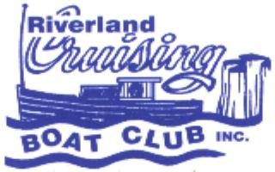
P.O. BOX 1496,

RENMARK, SOUTH AUSTRALIA 5341

Email: secretary@riverlandcruisingboatclub.org.au

Website: www.riverlandcruisingboatclub.org.au
ABN: 46 457 392 781
BSB 105052 Account: 504 891 40

The Riverland Cruising Boat Club is a social club which commenced in 1986 as part of the 150th birthday celebrations for South Australia. That year, a run from Renmark to Morgan was held, and it was so enjoyable that the club was formed with the aim of promoting and supporting responsible enjoyment of the River Murray. The club is run by a committee of volunteers. A major event, the ‘River Run’ is organized every 2 years, usually a 10 day cruise upstream or downstream of Renmark.

In the alternate years, a one week camp is held somewhere on the river. ‘Dinghy Dawdles’ in various locations (sometimes on a different river) are held in between these events.

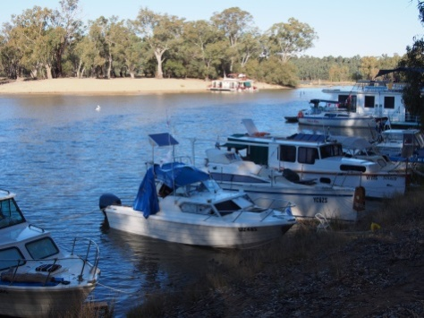
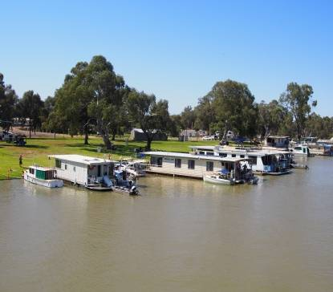
An informative newsletter is also distributed at least twice a year via email.

New members are welcome – if you would like to join please complete the form below.

If you require more information please contact Lissa Selga, Secretary on the email above or M: 0438 867 863.
This form can be filled in on your computer and emailed, or else printed and completed then scanned and emailed or returned by post. Membership is $50 for a couple or $35 for a single and expires at the end of the financial year.

Member 1 details.

Name

Address
Phone (Mobile preferred):
Email address:
Member 2 details.
Name

Address
Phone (Mobile preferred):
Email address:
PTO

Boat details 1

Type of Craft:
Boat Name:
Boat length
Boat Registration Number:
Boat details 2
2
Type of Craft:
Boat Name:
Boat length
Boat Registration Number:
Permission for use of photos: I give permission for images of me and/or my boat/s to be used in RCBC advertising, on the website and in the RCBC newsletter |  |  | Yes No
PAYMENT DETAILS
Today’s Date:
Cash/Cheque enclosed for $  Please post cheque and this form to above address. |  |  | Yes No
OR $ deposited to RCBC bank account | BSB: 105052  Account No: 50489140 |  | Online Receipt number
Please also email online payment confirmation and form to secretary@riverlandcruisingboatclub.org.au

